Conference Venue
EPUNet2006 will be held on the campus of the Universitat Pompeu Fabra (UPF) close to the Parc de la Ciutadella in the Olympic village, close to the centre of the city.

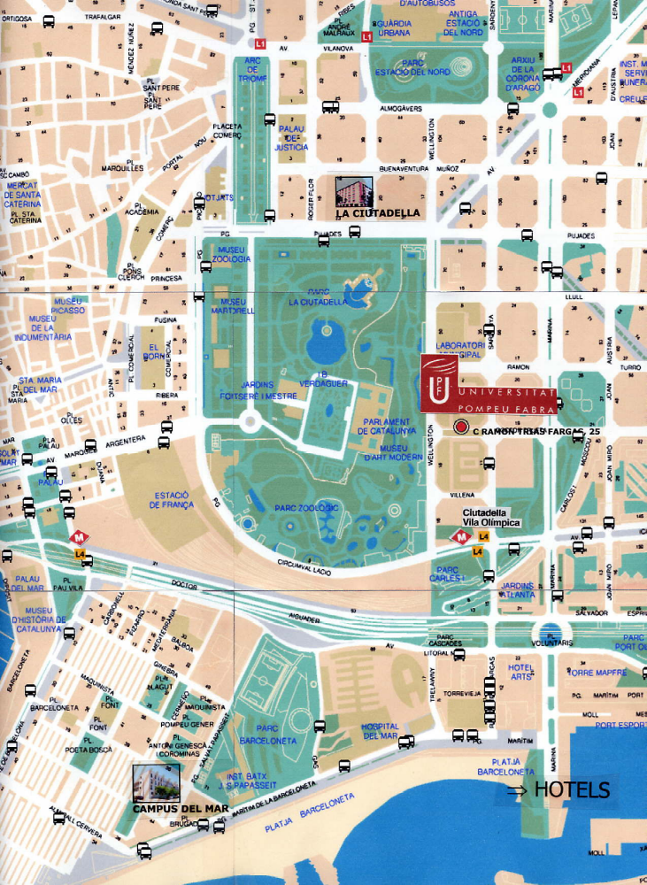

Conference sessions will be held in the Roger de Luria Building on the Ciutadella Campus, The address is:
Ramon Trias Fargas 25-27
Barcelona
08005 Barcelona

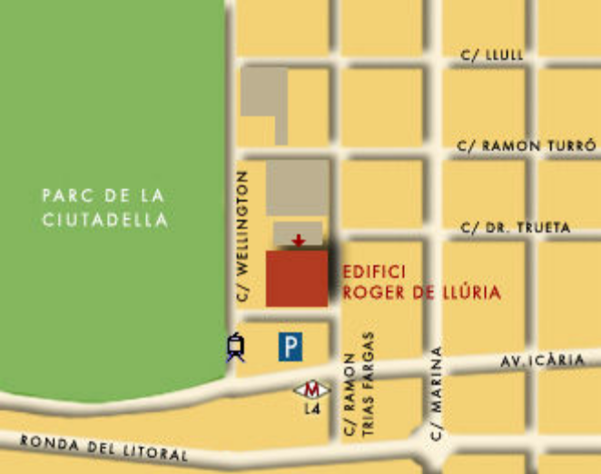

The closest subway/metro stop is “Ciutadella/Vila Olimpica” (yellow line or L4).

To reach the conference from the Residence “Campus del Mar”, it is a ten minute walk. The #45 and #59 buses are also possible.

To reach the conference from the Residence “La Ciutadella”, it is a 5 minute walk.

From the Hotel Marina H10, it is a 5 minute walk. The closed subway stop to the Hotel is Bogatell Station on L4.

Getting to Barcelona

Many airlines fly to Barcelona. Particularly cheap flights can be obtained from easyjet (http://www.easyjet.co.uk/)which flies to Barcelona Airport) and Ryanair (http://www.ryanair.com/)which flies into Gerona Airport about 1 ½ hours outside Barcelona. Air Berlin (http://www.airberlin.com/) flies to Barcelona from cities throughout Europe. Buzzaway (http://www.buzzaway.com/ ) offers links to many cheaper airline booking possibilities.

Getting to Pompeu Fabra from the Airport

By Aerobus – approximately 30 minutes and the easiest option

From the airport
Mon-Fri from 6 a.m..to 24:00
Sat-Sun/holidays from 6:30 a.m. to 24:00
Fare: One-Way 3.50 Euro

From Plaza Catalunya

Mon-Fri from 5:30 a.m. to 23:15
Sat-Sun/holidays from 6:00 a.m. to 23:15
Fare: One-Way 3.50 Euro

Frequency: every 15 minutes
Stops: Plaça Catalunya, Passeig de Gràcia-Diputació, Avinguda Roma-Urgell, Sants, Plaça Espanya, Airport: Terminals A, B, C.

From Passeig de Gràcia-Diputació, take the yellow line (L4) to either La Cuitadella or Bogatell.

See http://www.tmb.net/en_US/barcelona/moute/planols/planols.jsp for more details

By Train – approximately 45 minutes (see http://www.renfe.es/cercanias/barcelona/index_horarios.html for details)

- Take the RENFE train Line 1 at the airport

- Get off at EL PRAT DE LLOBREGAT , take a train to BARCELONA SANTS and then a train to Arc de Triomf Station.

- If you are staying in a city centre hotel, get off before Arc de Triomf at Plaza Catalunya and use any of the metro lines as appropriate ;

- If you are staying at the Hotel Marina, get off at Plaça Catalunya and go round the corner to Estació URQUINAONA and take Line 4 to Bogatell station, then a 10 minute walk to the hotel)

- If you are trying to get directly to the University, get off at Arc de Triomf Station and then go down the Passeig de Llius Companys until the reach Passeig de Pujades and turn left into the Passeig de Pujades until you reach Ramon Trias Fargas, turn right and Pompeu Fabra University is at number 25.

Fare: One-Way 2:30 Euro (purchase ticket at station)

By Taxi:
It takes approximately 30 minutes to reach the city centre. Approximate price: is 25 euros.

Accommodation

The area has a number of accommodation possibilities, but we recommend that you make your bookings as early as possible.

The closest hotel is the H10 Marina Barcelona, Av. Bogatell. 64-68, Old Town, E-08005. The University Pompeu Fabra has negotiated a special rate at this hotel which has been extended to Conference participants for a limited number of rooms. This is approximately Euro 148 for a double room for two people, Euro 126 for a double room for single occupancy. Contact them via email (at grupos.hmb@h10.es) or telephone Amparo Pérez who is in charge of reservations and groups on +34 93 320 99 54, and mention both Pompeu Fabra and the EPUNet 2006 conference.

A more reasonable alternative are the two UPF student residences: Campus del Mar and La Ciutadella.
(http://epunet.essex.ac.uk/Conf2006/Aparthotel_bcn_eng_0506.pdf ) You can write to resa@resa.es and reserve a room if any are still available. You must provide the following information in English or Spanish:

Date of arrival:
Date of departure:
Type of room (single or double):
Name and Surname:
No. of Passport:
Type of credit card:
Number of credit card:
Expiry date (mm/yy):
Your contact information (telephone):

Alternatively, you can write directly to the largest of the two residences, the Campus del Mar (campusdelmar@resa.es) attaching the completed form found at the end of this document.

Other hotels in the area can be found at any of the hotel websites for Barcelona. You might try Octopus Travel (OctopusTravel.com) for good discount rates for hotels.

General Information on Barcelona

A particularly nice website on Barcelona as a tourist centre is http://www.barcelonaturisme.com/.

Also, Basic Survival facts on living in Barcelona which contains much useful information for the visitor can be found at http://www.upf.es/international/exchange/index.htm?opcio=1. Extracts from this site relate to:

The Metro
Barcelona has two interconnected underground train systems: the Metro, comprising five lines, and the Ferrocarrils de la Generalitat de Catalunya (FGC) http://www.fgc.es/, which has two metropolitan lines and another four which go beyond the city limits.
Metro operating hours: Monday to Thursday, Sunday and public holidays, from 5.00 a.m. to 12 midnight; Fridays, Saturdays and eve of public holidays, from 5.00 a.m. to 2.00 a.m

Buses
While slower, the buses have the advantage of allowing you to enjoy the city while you travel. Each route is indicated at the corresponding bus stop.
Operating hours: from Monday to Sunday, from 4.30 a.m. to 11:30 p.m.
For further information, see TMB.( http://www.tmb.net/eng/home.htm)
Nitbús (the all-night bus)
Operating hours: from Monday to Sunday, from 11 p.m. to 4.00 a.m. buses leave at intervals of between 30 and 45 minutes.
They all stop at Plaça Catalunya. Nitbus website(http://www.emt-amb.com/links/nitbus.htm)
Taxis
Barcelona's taxis with their distinctive black and yellow livery, show a green light to indicate that they are available. They can be hailed by simply raising your hand. The taxi meter shows the fare to be paid. However, there are a number of authorised extra charges (for example, an airport charge, for extra baggage, etc.). Taxis will not accept more than four passengers.
Taxis can also be called from the following numbers | 93 303 32 66 | 93 3577755 | 93 2250000 | 93 3001100 |
Or visit www.taxibarcelona.com (http://bcnweb2.bcn.es:8885/taxi/Welcome.html)
And for a taxi adapted for the disabled the number is 93 358 11 11.

If you have any queries or experience any difficulty in using the information provided here, contact us at epunet2006@isermail.essex.ac.uk.

 | UNIVERSITY RESIDENCE CAMPUS DEL MAR  PASSEIG SALVAT PAPASSEIT, Nº 4  08003 BARCELONA  Tel. (0034) 93 390 40 00  Visita virtual R. Campus del Mar
How to book:
- Fill in the booking application form (Forms with incomplete data will not be valid)
- Send it by e-mail (campusdelmar@resa.es) or by fax: (+34) 93 310 66 27
- Wait for confirmation
BOOKING REQUEST
Personal data: (Passport or Identity is essential to proceed your reservation request)

Name: | Surname(s):
Address: |  | Post code:
Town: | Region: | Country:
Nº PASSPORT: | Telephone:  Fax: | E-mail:
Booking:
Check-in day (dd/mm/yyyy) – Check-out day (dd/mm/yyyy):
__ __ /__ __ /__ __ __ __ /__ __ /__ __
No. of single rooms:  No. of double rooms:  No. of additional beds for children: | No. of adults:  No. of children:
Comments:

Booking data: (You must fill in all the fields otherwise your reservation will not be valid.)
Type of credit card: | Number of credit card: | Expiry date (mm/yy):
Payment and cancellations:

- Stays up to 30 days: The payment must be made on arrival to the residence. Bookings cancelled within a period of less than 48 hours before the check-in day will be penalized with the fees of one night for person.
- Stays of more than 30 days: A pre-payment of 30% of the fees for the stay must be made in advance. Cancellations will be penalized with the total of the 30% of the fees paid in advance.

Deposits must be made in the following bank account:
SIRESA BARCELONINA, S.A. CAIXA CATALUNYA Bank account: 2013-0654-80-0200585165. Swift code: CESCESBBXXX IBAN: ES74-2012-0654-8002-0058-5165
When the customer receives confirmation of the booking, he/she must send in a maximum of 72 hours the bank proof of payment to the following fax number: (+34) 93 218 32 50, otherwise the booking will be cancelled.
The rest of the payment must be made on arrival to the residence.

IT IS INDISPENSABLE TO PROVIDE THE CREDIT CARD NUMBER AS A GUARANTEE OF THE BOOKING, FOR EVENTUAL PENALIZATIONS BECAUSE OF CANCELLATIONS AND FOR EVENTUAL DAMAGES TO THE RESIDENCE’S PREMISES OR EQUIPMENT.
Note: This booking is provisional. It will not be effective until confirmation is sent via e-mail or fax (within a maximum of 4 days). All requests must be signed by the customer according to the clauses mentioned.
Date and customer’s signature: Date and signature of the owner:

In compliance with the Organic Law 15/1999, of December 13, on Personal Data Protection, we inform you that the personal data contained in the booking request form will be included in a computer file named “CLIENTS”, whose ownership corresponds to the companies RESIDENCIAS DE ESTUDIANTES, S.A. (RESA) and to the concessionary company, SIRESA BARCELONINA, S.A. These personal data will be used by the companies mentioned for the correct management and fidelity maintenance of the clients, including the commercial promotion of the services offered, meaning that the filling of this form implies the consent to receive such a treatment. We also inform you about the possibility of exercising, with regards to your personal data, the rights of access, rectification, cancellation and/or opposition, at the following address: RESA, c/ Roger de LLuria Nº 118 1º,08037- Barcelona.

